Nine veterans with PTSD went to Mexico for a psychedelic retreat. This is how they feel nearly a year later.
By Anderson Cooper
February 2, 2025 / 7:00 PM EST / CBS News
Last year, for the first time, the Veterans Administration announced it would begin funding its own clinical trials to treat post traumatic stress disorder, depression and addiction, using two psychedelic drugs psilocybin and MDMA. Even if these trials are successful, it would be years before the VA could prescribe either drug for its patients. Thousands of veterans who are suffering aren't waiting, desperate for help, they're attending psychedelic retreats in countries where the drugs are legal to use, mostly in indigenous ceremonies. This past March we were invited to join nine veterans who traveled to the west coast of Mexico for a psychedelic journey they hoped would finally help ease their pain.
They came to Mexico from all over the United States, a group of nine veterans — with invisible wounds that are hard to heal.
Their destination: a remote village near Puerto Vallarta for a week-long psychedelic retreat.
It was a voyage into the unknown, but a risk worth taking for TJ Duff, a former Navy sailor.
Anderson Cooper: Are you optimistic?
TJ Duff: Being optimistic is hard for me. Because I've been through a lot of therapy, a lot of different treatments. And not a lotta success.
Duff was 18 when he joined the Navy. Months into his first deployment aboard the USS Cole, he says he narrowly escaped death, when two suicide bombers attacked the ship in Yemen, killing 17 sailors.
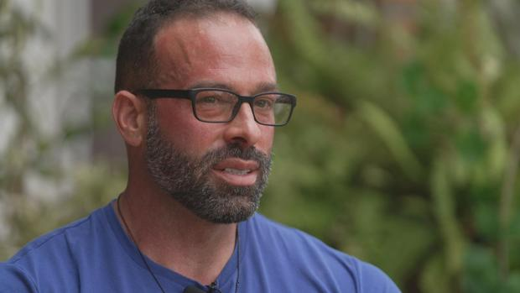TJ Duff60 Minutes
TJ Duff: Everyone around me was killed. There's bodies, alive and dead, being piled up in the midships. And-- I think that's really where I just started holding everything in.
Randy Weaver: Don't have it where I'm-- I'm jumping in ditches when I hear loud noises. My PTSD's-- is kind of a self-destructive form.
Randy Weaver is a police officer in New York. A former staff sergeant in the Army, he was diagnosed with PTSD in 2007, after returning home from tours in Bosnia, Iraq and Afghanistan.
Randy Weaver: It's the constant, you know, what if I had done this? What if we did that, you know?
Anderson Cooper: Are those things you want to revisit while you're taking the psilocybin?
Randy Weaver: Yeah. If I could revisit them-- and see them maybe from a different perspective like, not where I failed somebody.
Anderson Cooper: Is there a particular incident that you feel that you failed somebody?
Randy Weaver: Yeah. So-- March 18th, 20 years ago.
In 2004, Weaver's platoon was caught in a firefight in an Afghan village. Two soldiers were killed, one of them his friend, Staff Sergeant Anthony Lagman. Weaver's worn this bracelet with Lagman's name on it since coming home.
Anderson Cooper: You've been wearing that for 20 years.
Randy Weaver: Yeah. Every day.
Weaver says he's tried nearly every treatment for PTSD the VA offers including talk therapy, exposure therapy, meditation, and antidepressants.
Randy Weaver: You get to a point where you're-- you're so mentally exhausted and you've created so much destruction that you-- your demons tell yourself that these-- your family would be better off without you and when those demons tell you those things every day, it's somethin' hard to ignore.
Anderson Cooper: Will this help with that?
Randy Weaver: I hope so.
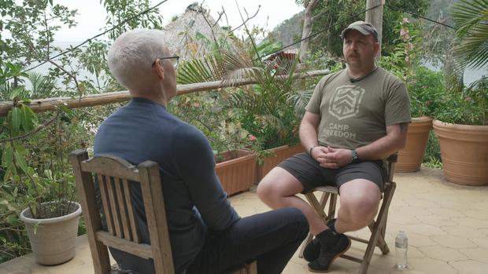Randy Weaver speaks with Anderson Cooper60 Minutes
The retreat was organized and paid for by the Heroic Hearts Project, a nonprofit that's helped more than 1,000 U.S. veterans with combat-related PTSD access psychedelics.
Ed Glover: I came home-- super angry, super anxious, hyper-vigilant. You know, that led to-- a pretty nasty divorce.
Ed Glover was in Afghanistan with the Marines. He's been a firefighter for 22 years.
Ed Glover: I feel like one or two traumatic events you may be able to recover from, but-- kind of seeing it day in, day out-- really takes its toll.
As the vets talked it became clear, some of their struggles began long before they joined the military.
Michael Giardina: My family life was just always this constant conflict.
Navy vet Michael Giardina had an emotionally abusive father who killed himself 16 years ago. His sister died by suicide five months before he came here.
Michael Giardina: My daughter asked my ex-wife if I was going to kill myself and I'm not. I just want to get better.
To qualify for this retreat, they had to work with their doctors to wean off any antidepressant or anxiety medication they might be taking because of how it could interact with the psychedelics. They also had to have a medical screening, and no family history of psychosis or schizophrenia. When we were there, a local doctor was on site but no mental health professionals.
Jesse Gould: I appreciate you guys for putting the-- the faith in me, the faith in us coming here.
Jesse Gould, a former Army ranger, founded the Heroic Hearts Project in 2017 after he tried another psychedelic, ayahuasca, at a retreat in Peru. Gould says psychedelics can help veterans revisit traumatic moments in ways they may be unable to with other therapies.
Jesse Gould: The value of what we're finding with psychedelics is it's a very individualistic journey. You know it comes at you. It brings up the emotions. It heightens your senses. And so you're having to face it. And-- so that's why you see such big revelations because it's giving you the tools to actually get there.
Anderson Cooper: Do you worry that some who see this as sort of a last hope may end up disappointed?
Jesse Gould: I worry that we're at the situation where people are having to go to other countries for their last hope that indicates a major flaw in the system.
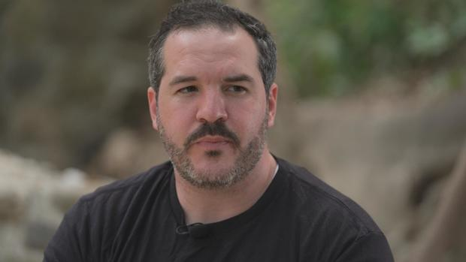Jesse Gould, a former Army ranger, founded the Heroic Hearts Project.60 Minutes
TJ Duff: The orange one? Ok
Heroic Hearts hired traditional healers to conduct three psychedelic ceremonies. The first two with psilocybin, a psychoactive compound found in some mushrooms. Its been used as medicine by indigenous communities in Mexico and elsewhere for centuries.
Healer: You don't need to be strong. All we need for this experience and to receive the healing is humbleness.
The healers stirred ground up mushrooms into a tea. The vets drank it, put on blindfolds to shut out distractions, and lay down.
At first it seemed like the group might have traveled thousands of miles for a midday nap. But then about an hour in, we saw Michael Giardina raise his hand for help. His foot soon started to shake, followed by his whole body. By hour three, it was clear the psilocybin had kicked in.
Randy Weaver and TJ Duff barely seemed to move. While firefighter Ed Glover appeared caught between rapture, and deep sorrow.
Five hours later, when the psilocybin began to wear off, the vets removed their eye masks and found the heat of the afternoon sun.
The next day the group gathered to discuss what they'd gone through.
Michael Giardina: It literally felt like an exorcism. My foot was goin' crazy, and I could kinda feel like my body was convulsing.
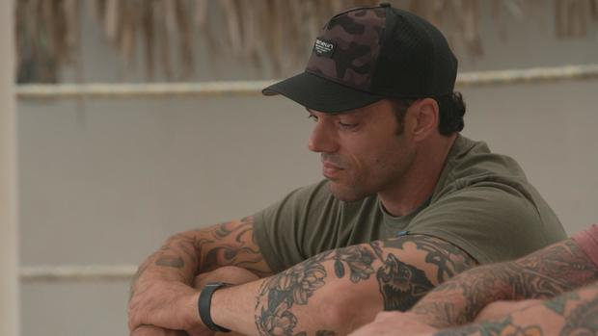Michael Giardina60 Minutes
Ed Glover: I felt like I was taking-- every last breath of any victim, patient, or friend that I had lost. So I really struggled to breathe yesterday
Randy Weaver: I've never done anything like that before.
…Randy Weaver appeared to find some of what he traveled all this way for.
Randy Weaver: One thing that I remember very vividly was flying back with the guys that-- that we lost like bein' on that medevac, even though I wasn't there in the real world. I was there s-- spiritually with them.
TJ Duff however, found it unsettling and at times scary.
TJ Duff: I've heard a lot of you guys stories and I did not get as immersive as you guys did. I'm kinda glad I didn't, honestly, 'cause I was kinda afraid of that.
That night Duff took part in another psilocybin ceremony, but the next day he left. He later told us the whole experience caused a dangerous decline in his mental health. He's now back on antidepressant medication.
The last ceremony of the retreat was with 5-MeO-DMT, a powerful and fast acting psychedelic secreted from a toad. After returning home, the vets had several virtual meetings with a heroic hearts project counselor.
Ed Glover: I think my biggest takeaway was making sure I make the time to take care of myself.
The Veterans Administration warns against "self-medicating" with psychedelics or using them as "part of a self-treatment program." But in December, when we spoke to its top doctor Shereef Elnahal, he was enthusiastic about their potential.
Anderson Cooper: Do these retreats concern you?
Dr. Shereef Elnahal: They can concern me because there's no way to monitor, certify-- make sure that they're actually safe environments. They're seeking these therapies because they do not see our current options for them to be effective enough, and they're in a state of desperation. And that, in and of itself, them seeking this type of unauthorized therapy, is just another indication on why we need to study this further, and get it to a safe and effective medical environment
In August, the FDA rejected a pharmaceutical company's application to use the psychedelic MDMA in combination with therapy as a treatment for PTSD, after an FDA advisory panel said there wasn't enough evidence it was safe or effective.
The VA is now conducting nine clinical trials using MDMA and psilocybin to treat PTSD, depression and addiction. Dr. Elnahal told us, a small phase two trial by the VA using MDMA and therapy to treat PTSD, completed last year, showed real promise.
Dr. Shereef Elnahal60 Minutes
Dr. Shereef Elnahal: 45% have gone into complete remission, which is essentially a "normal emotional state." That is unheard-of with prolonged exposure, cognitive processing, and certainly SSRIs, the current standard-of-care options.
Anderson Cooper: Almost half of the people who came in with PTSD and did MDMA therapy at the VA were cured?
Dr. Shereef Elnahal: Yes.
Anderson Cooper: So you have no doubt that this works?
Dr. Shereef Elnahal: We need to do larger Phase III clinical trials. That's the best way, scientifically, to understand what the true-- adverse events are and whether we can reproduce these results in larger populations of veterans. I'm very optimistic we will be able to demonstrate that.
Anderson Cooper: How long do you think it'll be before veterans can go to the VA and get this therapy
Dr. Shereef Elnahal: It could be another couple of years. The incoming administration is gonna take, you know, a pretty bold stance on this
Anderson Cooper: What makes you optimistic that the new administration is gonna be a believer in this?
Dr. Shereef Elnahal: We've heard the nominee for HHS-- Robert F. Kennedy, Junior, talk about what he thinks the potential breakthrough therapy is. We'll see what that stance is of other health officials, but that's really promising.
Nearly a year after that retreat in Mexico, we checked in with the nine veterans who attended. Eight of them told us their symptoms have improved and called their experience with psychedelics "life-changing."
Ed Glover says he still feels like a weight has been lifted off his shoulders.
Anderson Cooper: How are you doin'?
Ed Glover: Very well.
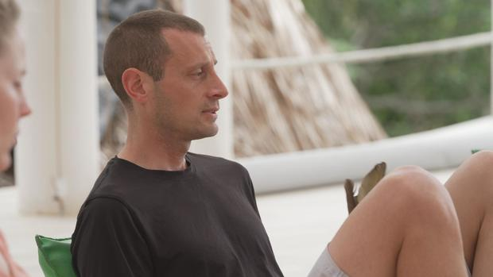Ed Glover in Mexico60 Minutes
Shortly after coming home from the retreat, he decided to retire as a firefighter.
Ed Glover: Prior to the retreat, I thought about takin' my life just about every day. I had a very close call. You know, the note, the gun. That is no longer the case.
Anderson Cooper: You haven't had thoughts of killing yourself since then?
Ed Glover: Not one.
And Randy Weaver says his suicidal ideations have stopped as well.
Randy Weaver: I don't have any of those thoughts since-- since goin' through-- through this journey.
Anderson Cooper: That's remarkable.
Randy Weaver: I would say yeah.
Anderson Cooper: You had told the-- the group afterward that you had visualized people on a medevac helicopter that you had served with.
Randy Weaver: Yeah.
Anderson Cooper: What-- what was the impact of that?
Randy Weaver: In combat things happen quickly. One minute you're talkin' to your friend and the next minute, you know, he's-- you're-- you're puttin' him in a body bag. That causes a gap in your psyche so to be able to revisit those incidences -- you know, seein' those helicopters come back with friends it brings a little-- peace to you, yeah.

